**Snack Vending Machine**

**Skeleton:**

Main class

SnackVendingMachineInt: high level methods

SnackMachineController : implement interface, initializing inventory items and inventory money slots

Item selection

Money bundle [coin,note]

Validation [item exist, valid money slots]

Inventory cash calculation

coinConvertion

sent change back to the customer

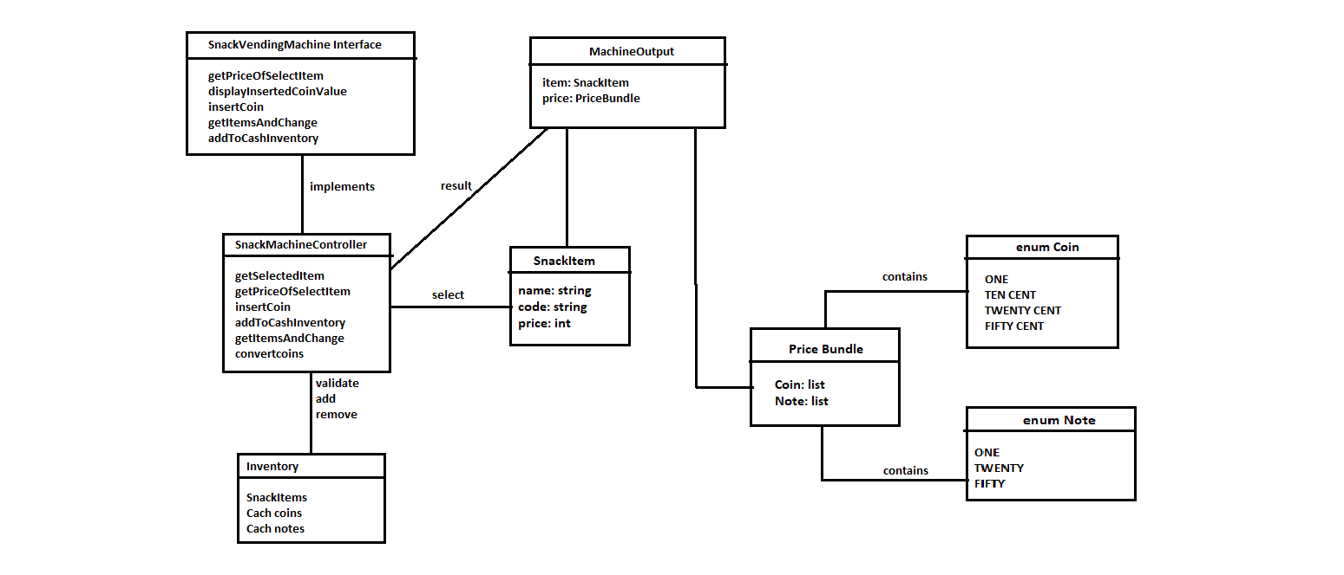**UML Diagrams:**